Fall 2014 - Bio. Sci. 4 - Plasmid and PCR Gels (page 1)

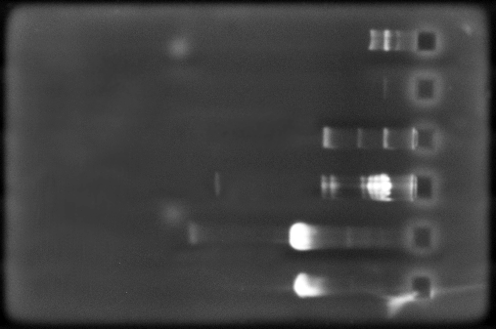  Gel #1 | 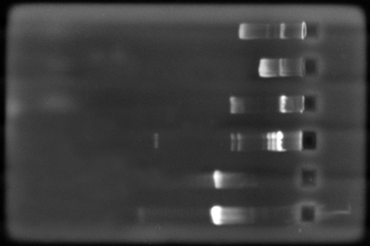  Gel #2
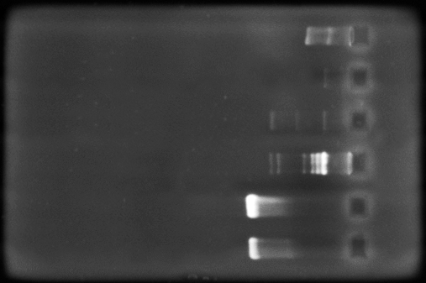  Gel #3 | 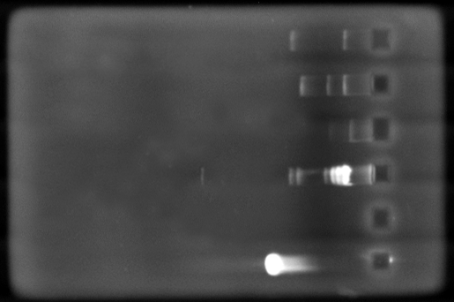  Gel #4
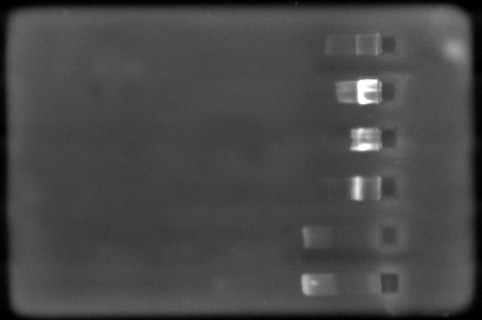  Gel #5 | 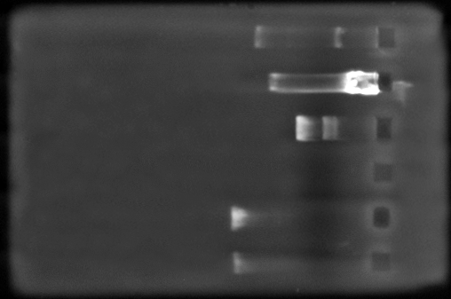  Gel #6

Lane numbers are 1-6 from top down. The calibration standard is Bacteriophage lambda DNA cut with the restriction enzyme Hind III for all gels (usually located in lane #4). Plasmid samples are pUC19, pGEM and pGLO. PCR product is 16S ribosomal DNA. RNA appears as faint white spots visible in some gels beyond the DNA.

Fall 2014 - Bio. Sci. 4 - Plasmid and PCR Gels (page 2)

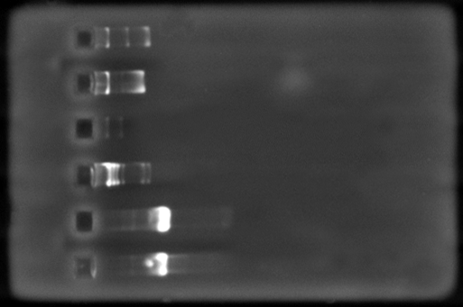  Gel #7 | 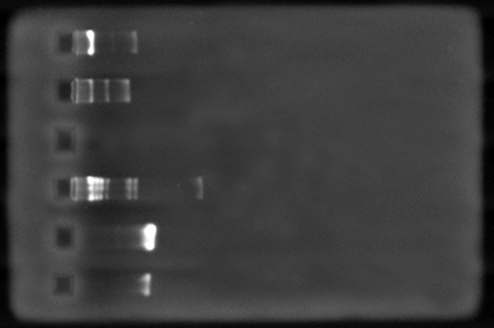  Gel #8
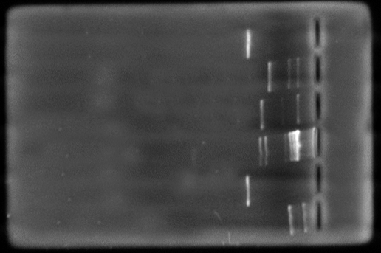
Gel #9

Lane numbers are 1-6 from top down. The calibration standard is Bacteriophage lambda DNA cut with the restriction enzyme Hind III for all gels (located in lane #4). Plasmid samples are pUC19, pGEM and pGLO. PCR product is 16S ribosomal DNA. RNA appears as faint white spots visible in some gels beyond DNA.

